**Chapter 4 suggested homework problems - SOLUTIONS**

4.3 This is a straight-forward line resistance calculation using basic formulas. Don’t forget to allow for twist – you may use a correction factor of 1.05.

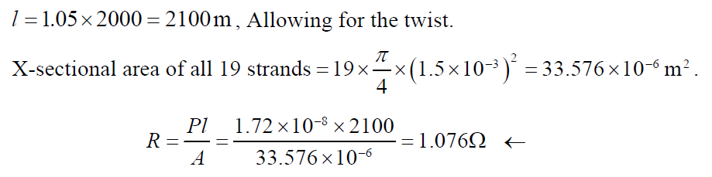

4.5 This is a resistance calculation where you can practice using the table. Remember that for multiple conductors, you *divide* by the number of conductors to find overall resistance.

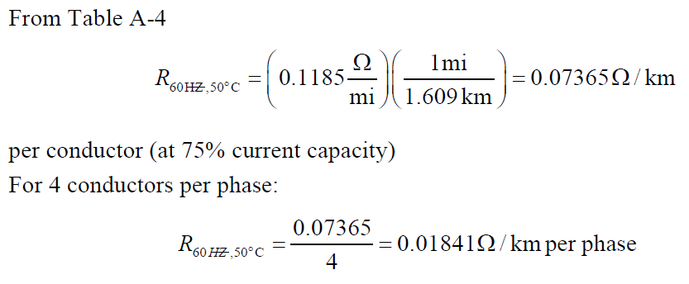

4.10 This uses basic principles (such as equation 4.5.10) to calculate inductance, in H/m, and then convert that to reactance, in ohms/km.

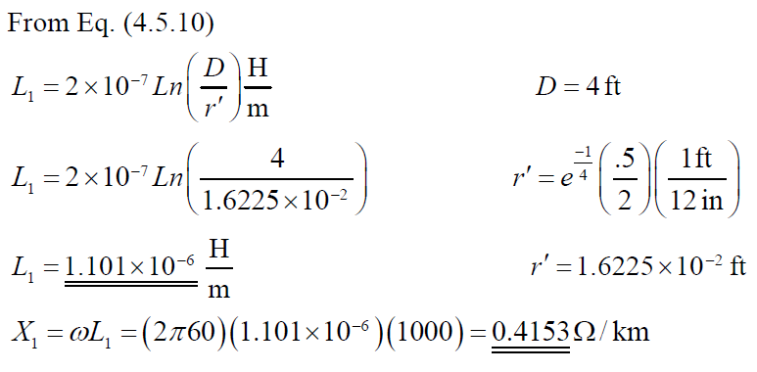

4.12 Here you can again use the table for practice.

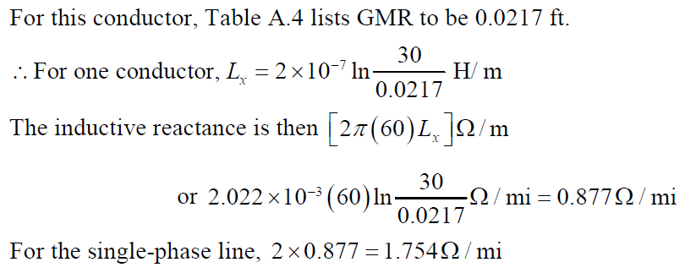

4.20 This is a straight-forward, three-phase line geometry problem using Table A.4 and some basic formulas from the reading.

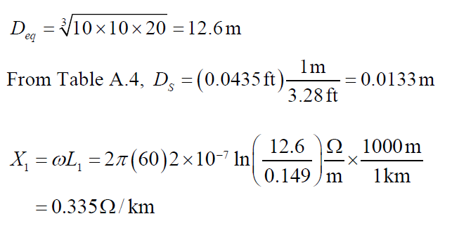

4.23 Another, more difficult, geometry problem using basic formulas to find the inductance per phase and then reactance per phase.

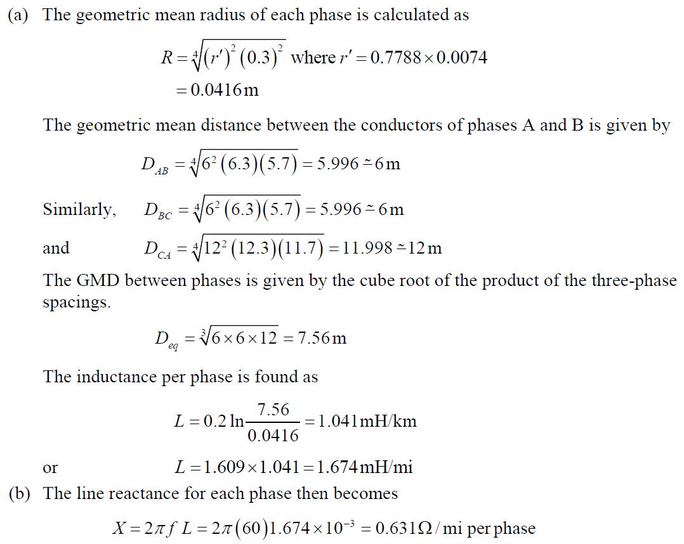

4.23 (cont.)

